Some Hints on Processor Testing

1. Write your own test cases in assembly. Here I will take the code below as an example.

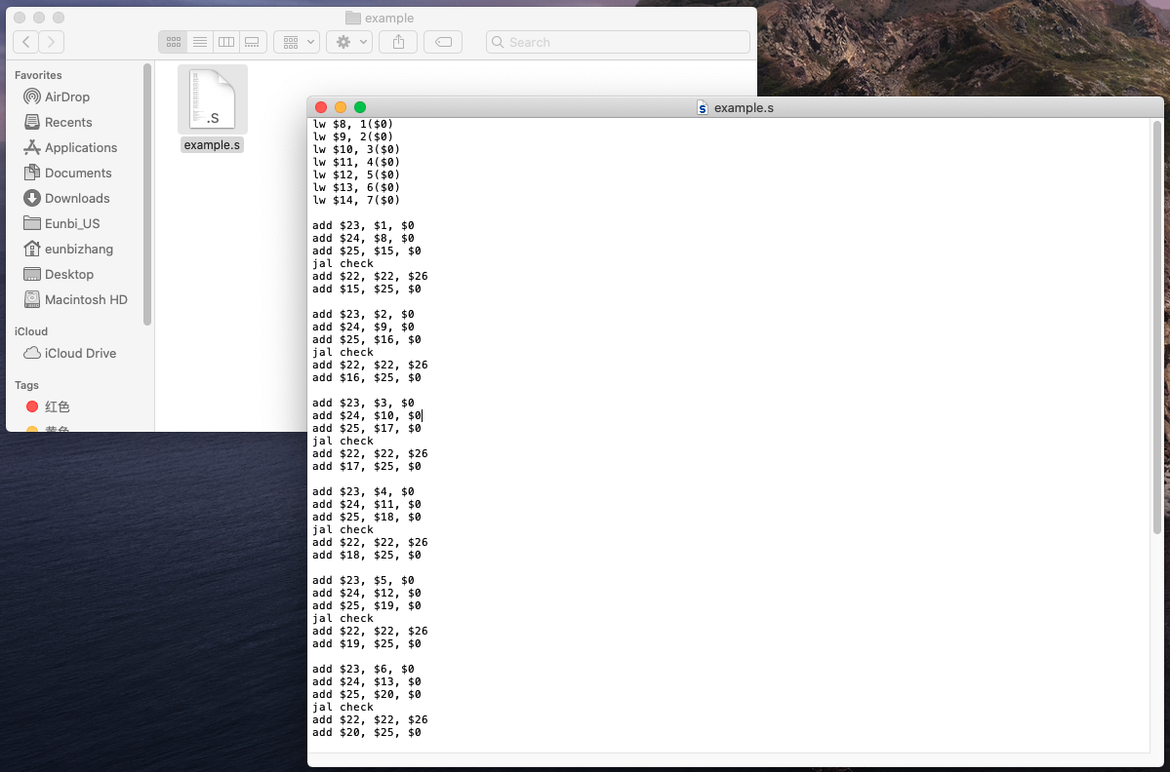

1. Download the ECE550_Assembler from <https://github.com/timlee0212/550-assembler/releases/tag/v2.1.0>.

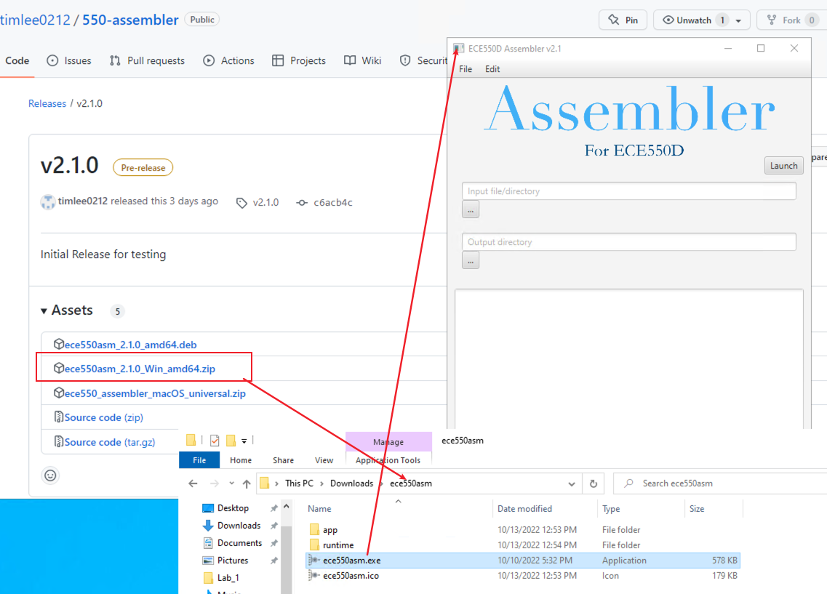

Here I am using Duke VM: Microsoft Windows 10 Version. You should be able to run the executable file directly.

1. Select the .s file and get .mif file output after clicking “Launch”.

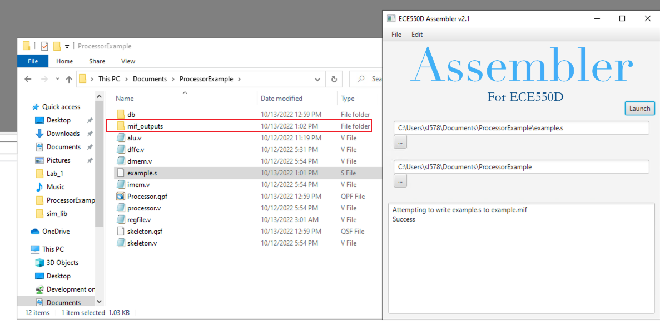

1. Now using the mif file to rewrite the imem of your Processor. It is a 1-port ROM on chip memory as shown below.

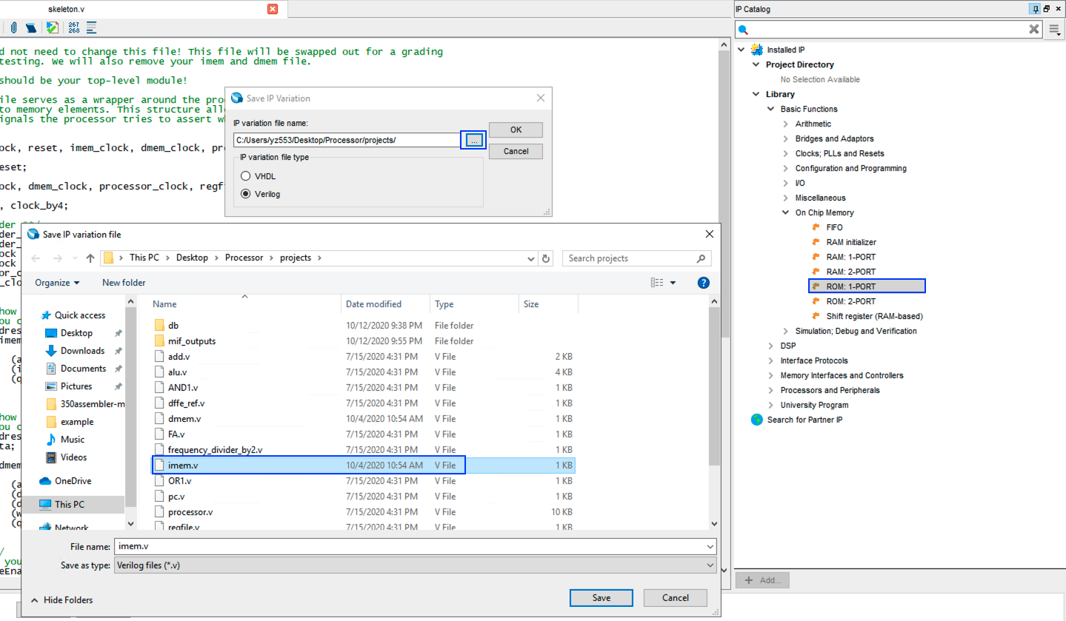

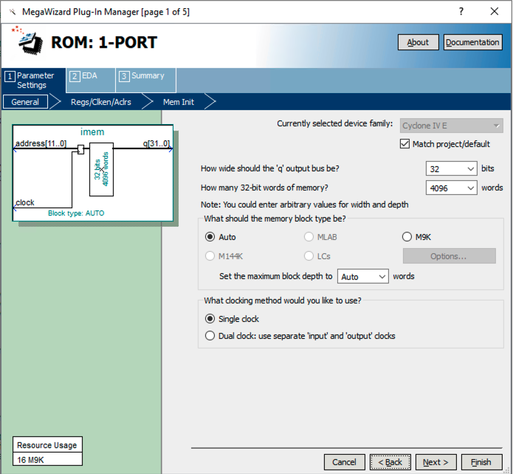

1. Initialize the imem content by using the .mif file that we got from assembler to load instructions you want to run on your processor.

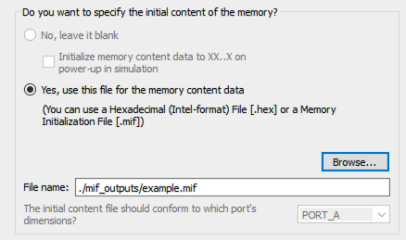

1. Similarly, generate your dmem, which is a 1-port RAM. Note you will want to leave it blank for initial content. You will never read data from some address of the dmem before writing data into that address.

